**PREDICTIVE MODELLING GROUP ASSIGNMENT**

**Group 1:**

**Prashanthi D Anand**

**Nivitha Natarajan**

**Subashree Bhaskaran**

**Vigneshwaran R**

**Avinash Kumar S**

**PROBLEM STATEMENT**

Cellphone dataset is provided with different variables. The variable and their description is as follows:

|  |  |
| --- | --- |
| **Variables** | **Description** |
| Churn | 1 if customer cancelled service, 0 if not |
| AccountWeeks | number of weeks customer has had active account |
| ContractRenewal | 1 if customer recently renewed contract, 0 if not |
| DataPlan | 1 if customer has data plan, 0 if not |
| DataUsage | gigabytes of monthly data usage |
| CustServCalls | number of calls into customer service |
| DayMins | average daytime minutes per month |
| DayCalls | average number of daytime calls |
| MonthlyCharge | average monthly bill |
| OverageFee | largest overage fee in last 12 months |
| RoamMins | average number of roaming minutes |

The objective is to train a model using a 70:30 split of dataset as training and test and predict the churn value.

**Solution:**

**Step 1 – Data Import :**

The Dataset is being imported using the below code.

cell <- read.csv(file.choose(), header=TRUE)

**Step 2 – Viewing and Understanding the Data.**

The below code helps us to view the data and understand the structure of the dataset.

head(cell, 6)

tail(cell, 6)

names(cell)

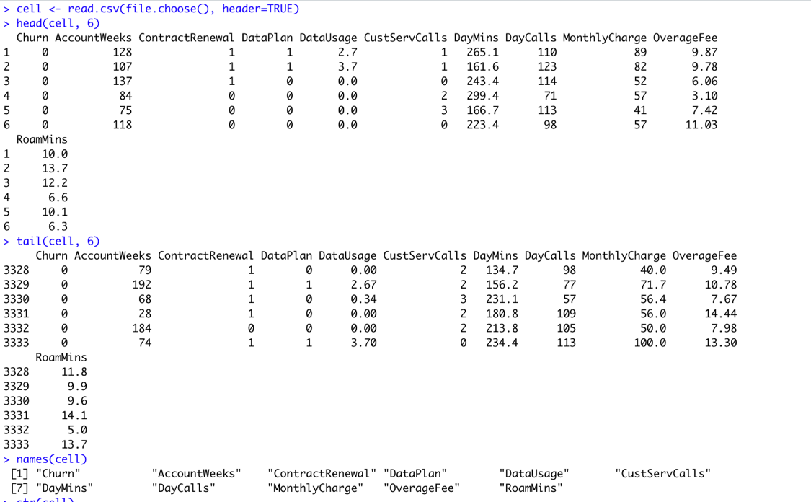

str(cell)

We have 11 variables with 3333 records, the **Target** variable (Y) is **Churn** and Variables like Contract renewal, Dataplan, Custservcalls have binary(0/1) values.

summary(cell)

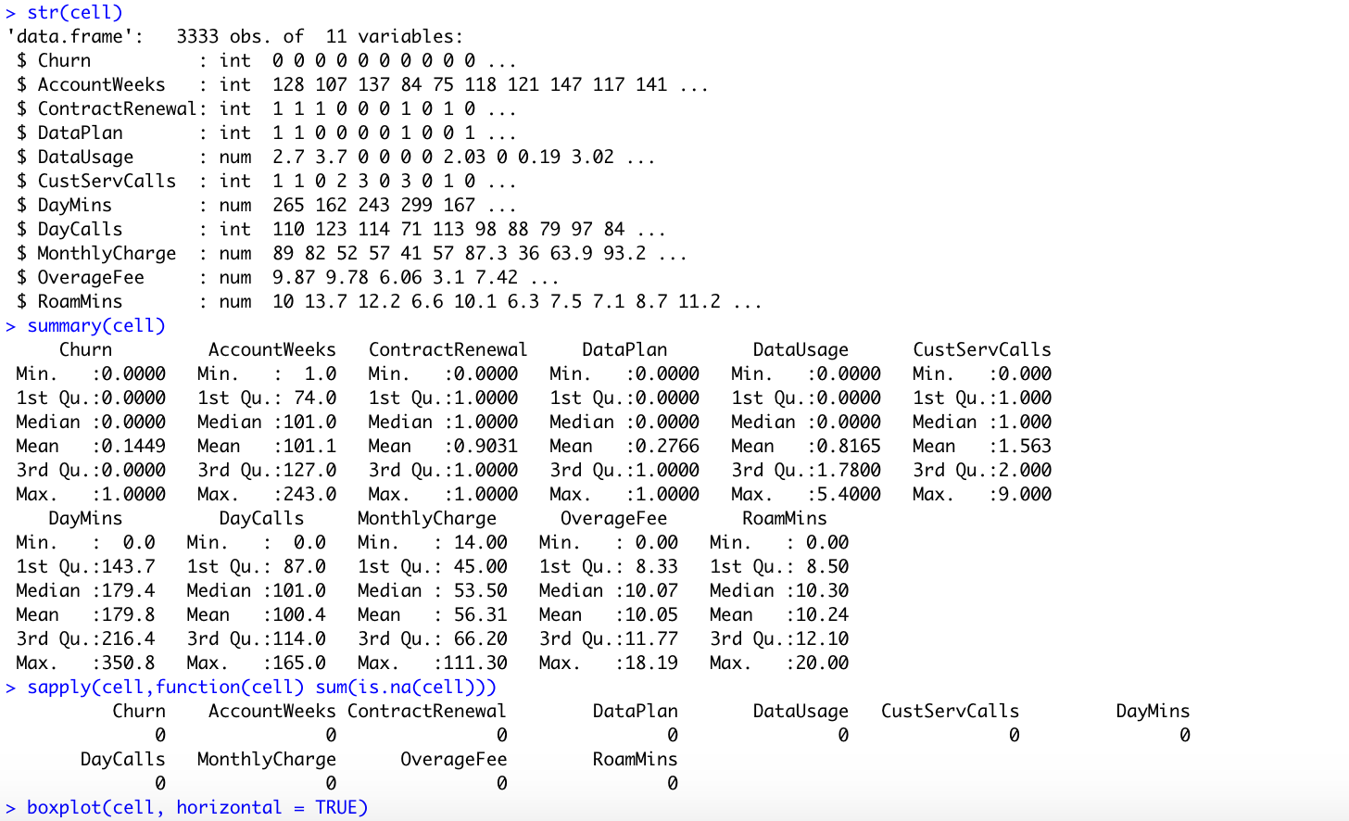

##Checking Missing Values and Outliers

sapply(cell,function(cell) sum(is.na(cell)))

There are apparently no missing values in the model.



boxplot(cell, horizontal = TRUE)

In general, there are outliers associated with certain variables. But there are not extreme outliers which will affect the modelling.

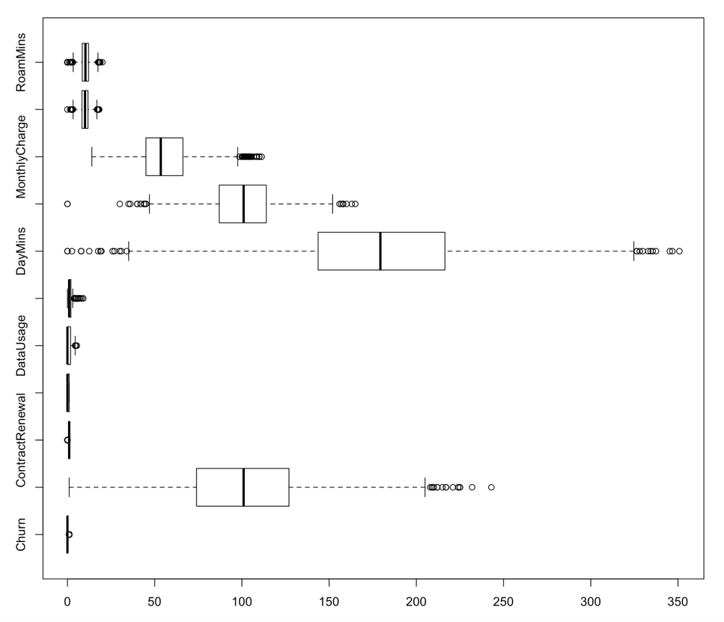

**Step 3 – Exploratory Data Analysis**

library(ggplot2)

ggplot(cell, aes(Churn, fill = "neon")) + geom_bar() +geom_text(aes(label=..count..),stat="count",position=position_stack(0.5))

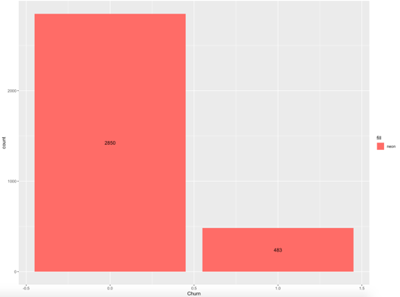

**Churn :** Around 483 customers have cancelled the plan (or) might have moved to the competition vendor.

ggplot(cell, aes(DataPlan,fill=Churn,color = "neon"))+geom_bar()+geom_text(aes(label=..count..),stat="count",position=position_stack(0.5))

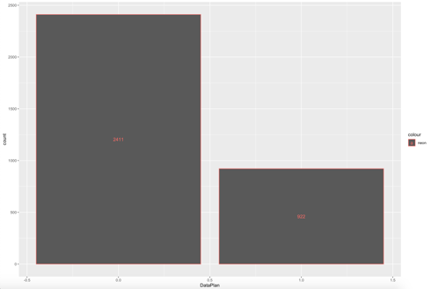

**Data Plan :** Around 922 customers have subscribed to the company’s data plan and 2411 are not under the subscription list.

ggplot(cell, aes(x=DataUsage,fill=as.factor(Churn))) + geom_histogram() + theme_classic()

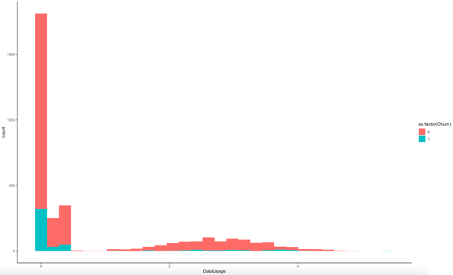

**Data Usage :** Most of the customers who have cancelled service seems to have used data usage slightly lesser as compared to another category.

ggplot(data, aes(x=DataPlan,fill=as.factor(Churn))) + geom_bar() + heme_classic()



**Data plan vs Churn :** From this graph, people have cancelled the service irrespective of the data plan.

400 of customers who did not have data plan, cancelled the service. Likewise, 80 customers with data plan have cancelled the service.

## Monthly Charge

boxplot(cell$MonthlyCharge)

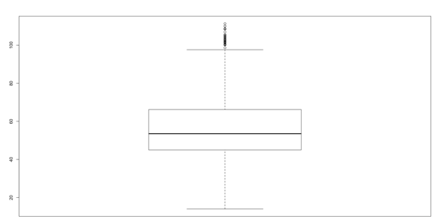

breaks <- c(10,20,30,40,50,60,70,80,100,200)

bins <- cut(as.numeric(cell$MonthlyCharge), breaks, include.lowest=TRUE,right=TRUE)

summary(bins)



ggplot(cell, aes(x=bins,fill=as.factor(Churn))) + geom_bar() + theme_classic()

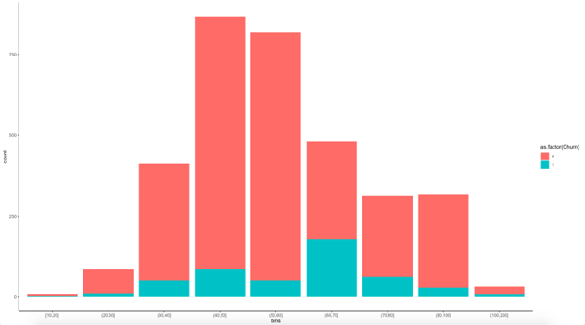

**Monthly Charge :** From the summary of bins, we may infer 8 customers are charged less than 20, 85 customers are charged in range of 21-30 per month, etc. From the graph beside, we get to know customers who are charged 61-70 monthly have higher churn rate.

ggplot(cell, aes(x=Churn, y=DayMins)) + geom_point() + stat_smooth(method="glm", se=FALSE)

ggplot(cell, aes(x=Churn, y=OverageFee)) + geom_point() + stat_smooth(method="glm", se=FALSE)

ggplot(cell, aes(x=Churn, y=RoamMins)) + geom_point() + stat_smooth(method="glm", se=FALSE)

Likewise DayMins, OverageFee, RoamMins are also equally distributed across customers.

**Step 4 – Correlation.**

library(corrplot)

corrplot(cor(sdata),method="number")



As the plot shows, following variables are highly correlated:

1. Data Plan and Data Usage highly correlated
2. Data Plan and Monthly Charge highly correlated
3. Data Usage and Monthly Charge highly correlated
4. Day Mins and Monthly Charge highly correlated

**Step 5: Model Building**

**Model 1:** Logistic Model with 70: 30 data split of data containing unbalanced distribution

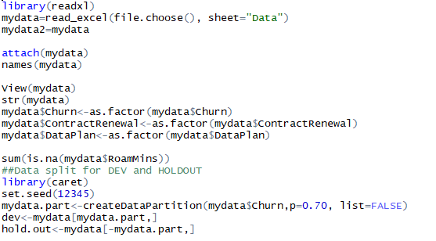

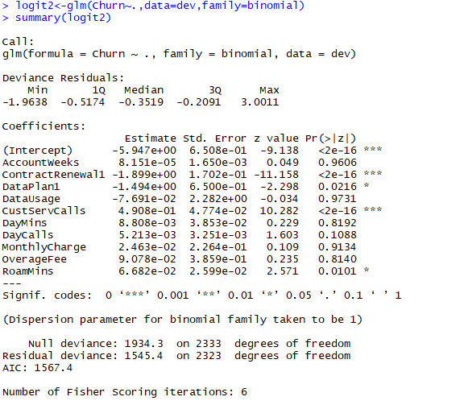

Likelyhood Test

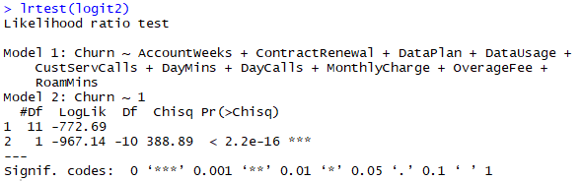

Pseudo R Square Interpretation



Odds and Probabilities

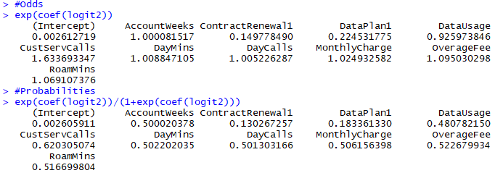

Prediction and Classification Table for Test Data

Confusion Matrix / Misclassification Error for Traindatax1

prediction = predict(logit2,hold.out[,2:11], type="response")

cutoff = floor(prediction+0.5)

cutoff = as.factor(cutoff)

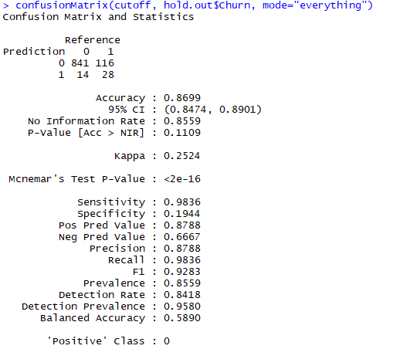

ROC Curve

library(JavaGD)

library(rJava)

Sys.setenv(JAVA_HOME='C:/Program Files/Java/jdk-12.0.1')

library(JGR)

library(Deducer)

rocplot(logit2)

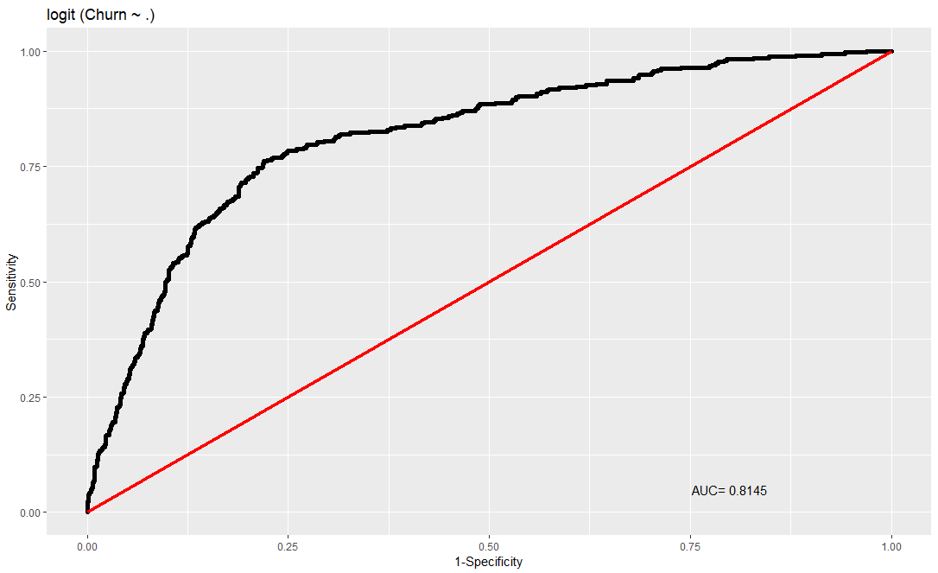

**Comment:**

Even though the accuracy of the model is 86%, there is a huge imbalance in distribution of churn data. In order overcome this imbalance we might have to manipulate the probability values to arrive at an accurate prediction or we can implement oversampling or proportionate sampling techniques.

**Model 2:**

For this model, we are training the data considering a proportionate sampling and we modify the probability value to improve the model performance. Before doing so, we try to identify the significant variables by an Exploratory data analysis.

**Step 5 – Packages Installation & Baseline Model Test.**

install.packages("caret")

library(lattice)

library(ggplot2)

library(caret)

library("caTools")

table(cell$Churn)

prop.table(table(cell$Churn))

**Baseline Accuracy : 2850/3333 = 85.5**

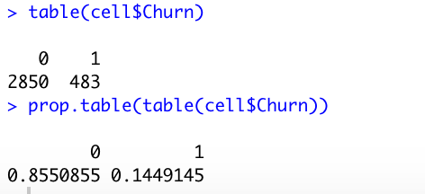

## Creating Training Data:

churn_ones <- cell[which(cell$Churn == 1), ]

churn_zeros <- cell[which(cell$Churn == 0), ]

set.seed(100)

churn_ones_training_rows <- sample(1:nrow(churn_ones), 0.7*nrow(churn_ones

churn_zeros_training_rows <- sample(1:nrow(churn_zeros), 0.7*nrow(churn_ones))

training_ones <- churn_ones[churn_ones_training_rows, ]

training_zeros <- churn_zeros[churn_zeros_training_rows, ]

cellTrain <- rbind(training_ones, training_zeros)

## Creating Testing Data:

test_ones <- churn_ones[-churn_ones_training_rows, ]

test_zeros <- churn_zeros[-churn_zeros_training_rows, ]

cellTest <- rbind(test_ones, test_zeros)

nrow(cellTrain)

nrow(cellTest)



**Log Model**

cellLog <- glm(Churn ~ .,data=cellTrain,family = binomial)

summary(cellLog)

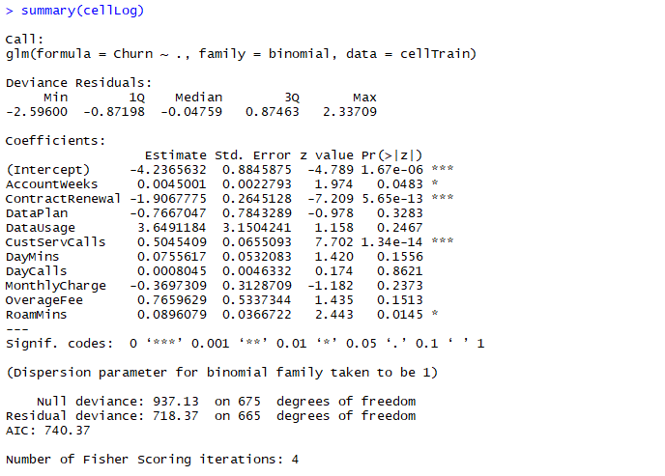

**Interpretation:**

The three significant variables highlighted in green are:

1. Contract Renewal

2. Customer Service Calls

3. Roaming Minutes

The AIC Score is 740.37. The model having a lesser AIC Score would be the most preferred and optimized one.

**LoglikelyHood Test Interpretation**

library(lmtest)

lrtest(cellLog)

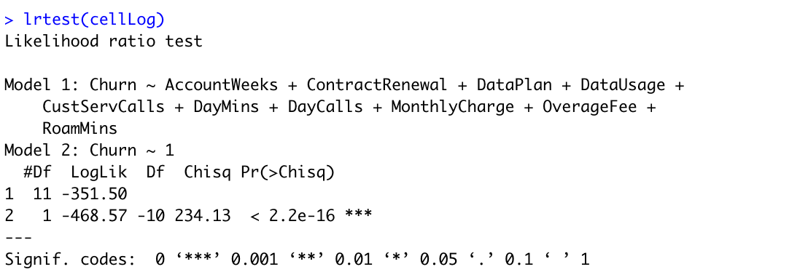

From the log likelihood, we can see that, intercept only model - 468.57 variance was unknown to us. When we take the full model, - 351.50 variance was unknown to us.

**Chisq likelihood ratio is significant.** Also the p value suggests that we can accept the Alternate Hypothesis that at least one of the beta is not zero. **So Model is significant.**

**Pseudo R Square Interpretation**

install.packages("pscl")

library(pscl)

pR2(cellLog)



**Interpretation:**

The McFadden’s pseudo-R Squared test suggests that at-least 24.98% variance of the data is captured by our Model, which suggests it’s a robust model.

**Individual Coefficient Beta Significance Interpretation**

As seen above, the variables highly significant are :

1. Contract Renewal

2. Customer Service Calls

3. Roaming Minutes

Running Odds and Probability Test :

## Odds

exp(coef(cellLog))



## Probability

exp(coef(cellLog))/(1+exp(coef(cellLog)))



**Interpretation:**

The above output is the particular variable “IF Increased by One Unit”, the odds of customer likely to churn and the Probability of Customer Churn will increase by n number of units.

E.g. When the Customer renews contract the odds customer will churn is 0.14 compared to when the customer doesn’t renew. Similarly, when the customer opts for Data Plan the odds the customer will churn is 0.19 compared to when the customer doesn’t opt.

**Confusion Matrix for Train Data**

cellTrain$Churn<-as.factor(cellTrain$Churn)

cellTrain$ContractRenewal<-as.factor(cellTrain$ContractRenewal)

cellTrain$DataPlan<-as.factor(cellTrain$DataPlan)

library(caret)

Trainpredict <-predict(cellLog,newdata=cellTrain,type="response")

ypredictnum <- ifelse(Trainpredict>0.5,1,0)

ypredict <- factor(ypredictnum, levels=c(0,1))

yaction <- cellTrain$Churn

confusionMatrix(ypredict,yaction,positive="1")



**Predicting Probabilities Using the model**

predictTrain <- predict(cellLog,type = "response")

summary(predictTrain)

predictTrain

## Mean of probabilies of each Churn Type

tapply(predictTrain,cellTrain$Churn,mean)

table(cellTrain$Churn,predictTrain>0.5)

table(cellTrain$Churn,predictTrain>0.7)

table(cellTrain$Churn,predictTrain>0.2)

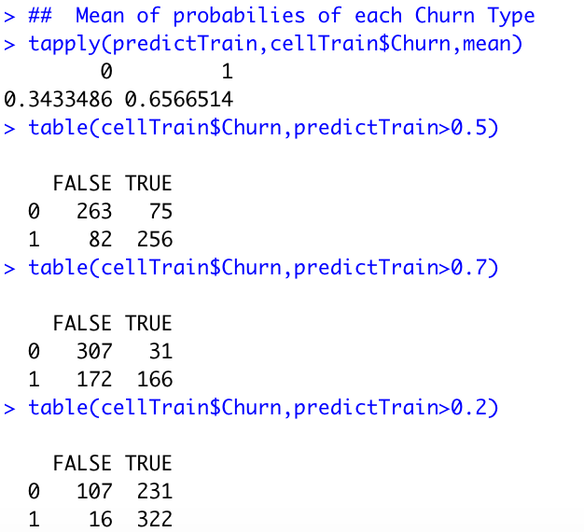

**ROC Curve**

install.packages("ROCR")

library(ROCR)

install.packages("gplots")

library(gplots)

ROCRpred <- prediction(predictTrain,cellTrain$Churn)

ROCRperf <- performance(ROCRpred,"tpr","fpr")

plot(ROCRperf)

plot(ROCRperf,colorize=TRUE)

plot(ROCRperf,colorize=TRUE,print.cutoffs.at=seq(0,1,0.1),text.adj=c(-0.2,1.7))

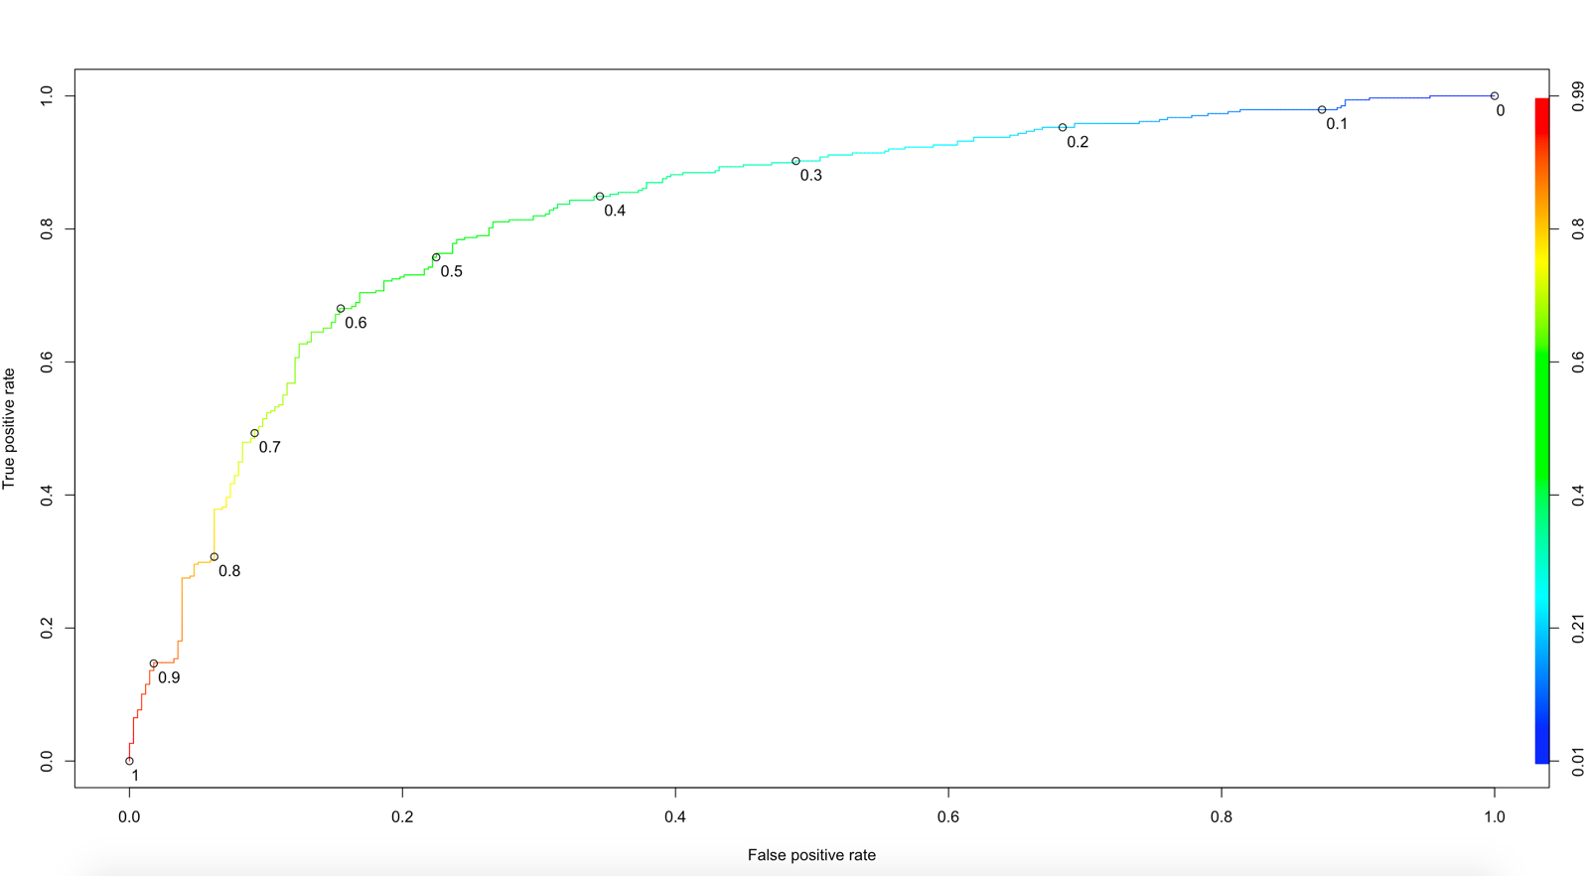

**Interpretation:**

ROC shows relationship between specificity and sensitivity i.e. find the relationship between TPR and FPR. Area Under Curve should be more for a good model. As a thumb rule, AUC between .80 and .90 is a good measure of the test. Here, the above curve is away from diagonal, which concludes the model **predicts with higher accuracy.**

**Test Data**

Classification Matrix for Test Data

Testpredict <-predict(cellLog,newdata=cellTest,type="response")

ypredictnum <- ifelse(Testpredict>0.7,1,0)

ypredict <- factor(ypredictnum, levels=c(0,1))

yaction <- as.factor(cellTest$Churn)

confusionMatrix(ypredict,yaction,positive="1",mode = "everything")

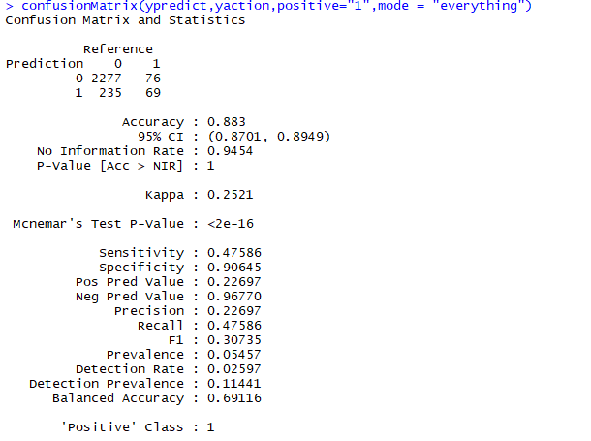

Prediction for Test Data

predictTest = predict(cellLog, type="response", newdata=cellTest)

ROCRpredTest = prediction(predictTest, cellTest$Churn)

table(cellTest$Churn,predictTest>0.5)

table(cellTest$Churn,predictTest>0.6)

table(cellTest$Churn,predictTest>0.7)

auc = as.numeric(performance(ROCRpredTest, "auc")@y.values)

auc

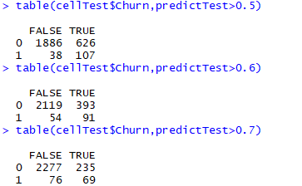

**Interpretation:**

The Accuary at threshold 0.5, 0.6 and 0.7 are 0.75, 0.83 and **0.88** respectively. **Since the Accuracy of Testing Data at 0.7 threshold is the highest we shall conclude with it.**

**ROC and AUC for Testing Data**

ROCRperf <- performance(ROCRpredTest,"tpr","fpr")

plot(ROCRperf)

plot(ROCRperf,colorize=TRUE)

plot(ROCRperf,colorize=TRUE,print.cutoffs.at=seq(0,1,0.1),text.adj=c(-0.2,1.7))

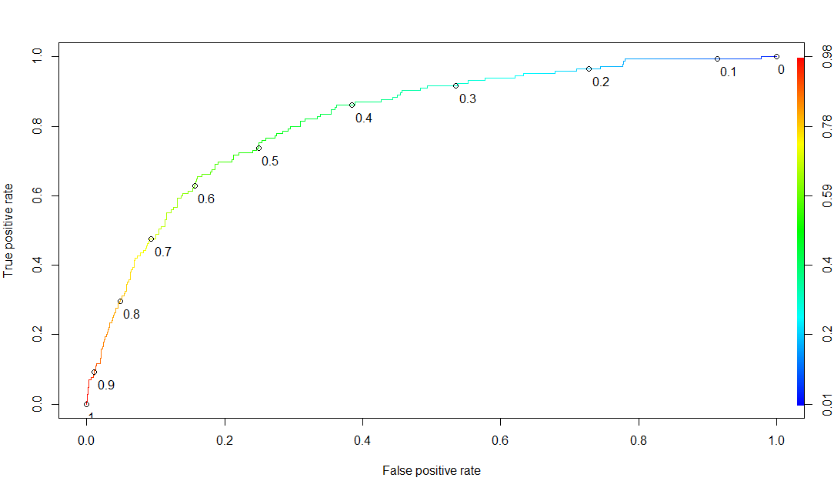

auc = as.numeric(performance(ROCRpredTest, "auc")@y.values)

auc

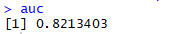

Accuracy is measured by the area under the ROC curve. An area of 1 represents a perfect test; an area of 0.5 represents a worthless test. **AUC At 0.8213, the ROC Curve of our model demonstrates fairly good results.**

**Model Comparison Chart :**

|  |  |  |
| --- | --- | --- |
| **Model Name** | **Model 1 – Logit2** | **Model 2 - cellLog** |
| Target Variable | Churn | Churn |
| Dependent Variables | All 10 Variables | All 10 Variables |
| Significant Variables | 1.Contract Renewal  2. Customer Service Calls  3. Roaming Minutes | 1.Contract Renewal  2. Customer Service Calls  3. Roaming Minutes |
| Loglikelihoods Test | Model is significant. | Model is significant. |
| Pseudo R Square | 0.2010 | 0.2498 |
| Predictive Test Model Accuracy at threshold 0.7 | 86.99% | 88.3% |
| Test Data AUC | 0.8145 | 0.8214 |

**Comments :**

Model 2 has a better accuracy compared to Model 1. Also by doing a proportionate sampling, the corresponding sensitivity and specificity values are impacted as well. The AUC shows a good improvement compared the baseline model.

From both the models it is evident that **Contract renewal, Customer service calls and Roaming minutes** are significant contributors to Churn rate. For example, the odds that a customer would change his cellphone carrier is 1.95 considering the service calls made by the customer.